**Name: Do Minh Quang  
ID: 10421051**

**Programming 1 – Project 2**

Project target: Given a template image containing an object and a set of background images, use the template to detect that object in a background images.

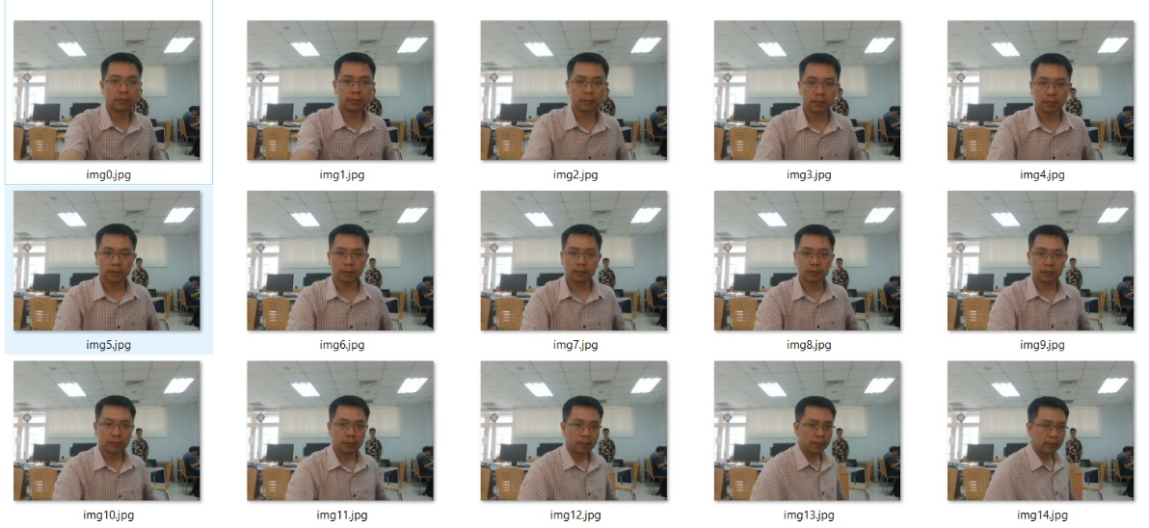

*Input*

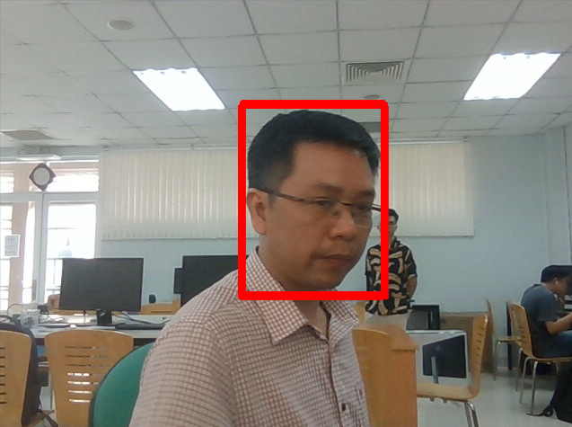

*Result1: object exists -> detectable*

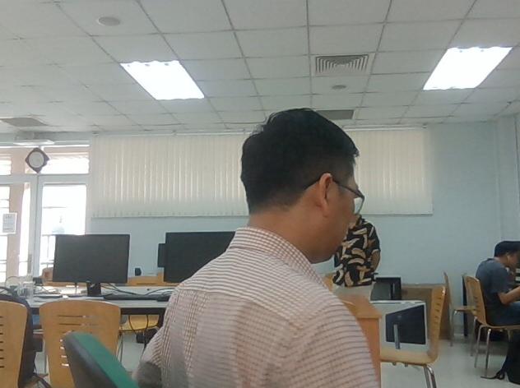

*Result2: object not exist -> can’t decect*

**Process of solution:**

**Idea**: slide the template over the image, calculate the likeliness between the area of the background and the template, if the likeliness is over a certain threshhold (over = object, under = not object) and draw the border of that area to red to mark the object.